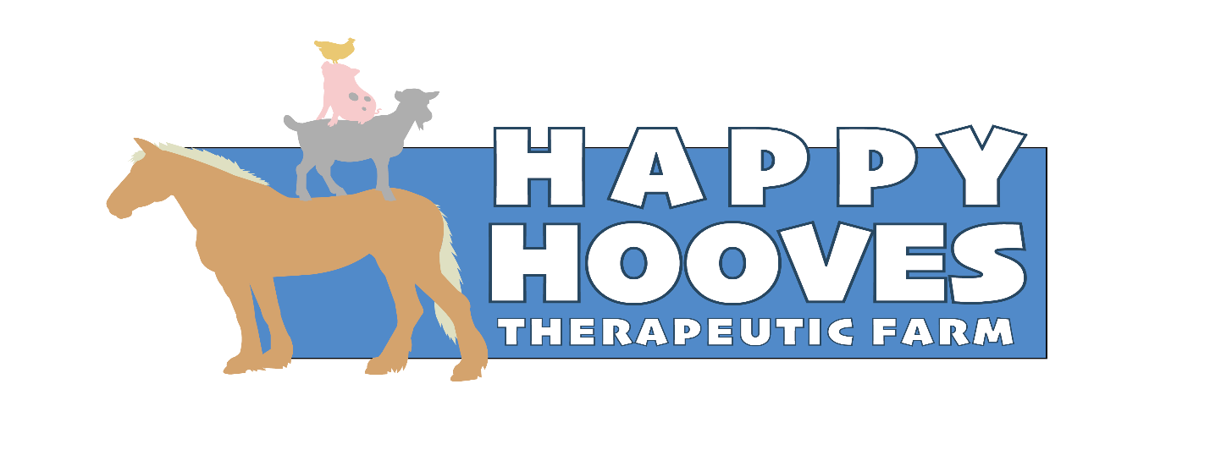

Contract for Volunteer and Participant

I, _____________________________ agree to familiarize myself with, and abide by all of the Happy Hooves Therapeutic Farm’s job descriptions, policies and procedures.
-I understand that all client information is confidential and should not be shared with anyone outside of Happy Hooves Therapeutic Farm Inc.
-I agree to allow Happy Hooves Therapeutic Farm Inc to use my photo, likeness or words in media releases and other Happy Hooves Therapeutic Farm Inc publications, both printed and online.
- I understand that I may be required to complete, pay for and provide a copy of my certificate for a valid Food Handlers or ServSafe Course.
- I understand that I may be required to complete, pay for and provide the results for a valid criminal background check done within the last 12 months.
- If my duties include driving for Happy Hooves Therapeutic Farm Inc, I understand that I must maintain a valid Driver's License and Auto Liability Insurance. In addition, I may be asked to provide copies of those items which may be subject to Department of Motor Vehicle driver's license background check.
- I agree not to accept personal payment for any services that I provide to our clients.
- I agree to do my best to communicate with the coordinators and give at least 2 weeks notice if I will not be able to fulfill my obligations.
- I understand that Happy Hooves Therapeutic Farm Inc is an evolving organization. We are committed to a culture of openness, warmth and understanding as we nurture each other, our clients and the larger community.

Participant and Volunteer Agreement and Release from Liability
- I agree to work as a volunteer or participate at Happy Hooves Therapeutic Farm Inc.
- As a volunteer, I understand that Happy Hooves controls the dates and times when I do the work and that Happy Hooves Therapeutic Farm Inc is responsible for scheduling my volunteer work. I also understand that I will not be compensated for any time spent volunteering, nor am I entitled to benefits, including employment insurance benefits upon the termination of this agreement or as a result of this service.
- I am aware that participation as a volunteer may require periods of standing, lifting and carrying up to 40 pounds and will require the exercise of reasonable care to avoid injury, including asking for assistance if uncomfortable (or unstable). I am voluntarily participating in this activity with knowledge of the hazards or potential dangers involved, and agree to accept any and all risks of personal injury and property damage.
- As consideration for volunteering and participating at Happy Hooves Therapeutic Farm Inc, I hereby agree that I, and my assignees, heirs, guardians, and legal representatives, will not make a claim against or sue Happy Hooves Therapeutic Farm Inc or its employees, agents or contractors for injury or damage resulting from the negligence, whether active or passive, or other acts, however caused, by any of its officers, employees, agents, or contractors of Happy Hooves Therapeutic Farm Inc as a result of my volunteering or participating.

I HEREBY RELEASE AND DISCHARGE HAPPY HOOVES THERAPEUTIC FARM INC AND ITS DIRECTORS, OFFICERS, EMPLOYESS, AGENTS AND CONTRACTORS FROM ALL ACTIONS, CLAIMS, OR DEMANDS THAT I, MY HEIRS, GUARDIANS, AND LEGAL REPRESENTATIVES NOW HAVE, OR MAY HAVE IN THE FUTURE, FOR INJURY OR DAMAGE RESULTING FROM MY PARTICIPATION. I UNDERSTAND THAT IF I AM INJURED IN THE COURSE OF VOLUNTEERING OR PARTICIPANTING FOR HAPPY HOOVES THERAPEUTIC FARM INC, I AM NOT COVERED BY HAPPY HOOVES THERAPEUTIC FARM INC WORKERS' COMPENSATION PROGRAM.

I authorize Happy Hooves Therapeutic Farm Inc to seek emergency medical treatment on my behalf in case of injury, accident or illness to me arising from my involvement as a volunteer or participant. I understand that I will be responsible for medical costs incurred by such accident, illness or injury. I understand that the materials and tools provided by Happy Hooves Therapeutic Farm Inc are and remain the property of Happy Hooves Therapeutic Farm Inc and I agree to return these tools and any remaining materials to Happy Hooves Therapeutic Farm Inc at the end of my volunteer service or participation.

I HAVE READ THIS AGREEMENT AND FULLY UNDERSTAND ITS CONTENTS. I AM AWARE THAT THIS IS A RELEASE OF LIABILITY, AND SIGN IT OF MY OWN FREE WILL.

Happy Hooves Therapeutic Farm Inc Policy
It is the policy of Happy Hooves Therapeutic Farm Inc to provide equal opportunities without regard to race, color, religion, sex, national origin, ancestry, age, order of protection status, marital status, physical or mental disability, military status, sexual orientation, pregnancy, or unfavorable discharge from military service or any other characteristics protected by law.

Print Name of participant or Volunteer ___________________________________________________

Signature of participant or Volunteer ______________________________________ Date ____________
(signature from parent or guardian if participant or volunteer is under 18 years old)

